**National University of Computer & Emerging Sciences, Karachi** 

|  |
| --- |

|  |
| --- |

**Computer Science Department** 

**Fall 2024, Lab Tasks - 05**

| **Course Code: CL-1000** | **Course: Introduction to Information and Communication Technology (IICT)** |
| --- | --- |
| **Instructor(s):** | **Yumna Asif** |

1. Run SQL Command Line and Enter the following statements to create a new database: 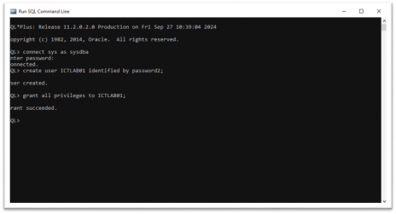2. Now open SqlDeveloper and open the following database:

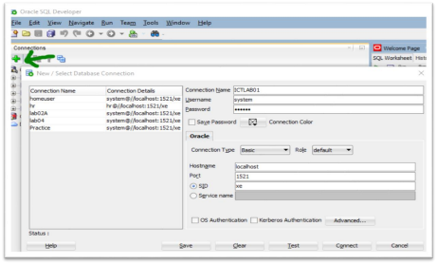

3. Now Copy and Paste the following Records, and then SELECT ALL THE RECORDS AND CLICK THE RUN STATEMENT (GREEN ARROW) BUTTON:

CREATE TABLE employees (

employee_id NUMBER(6) PRIMARY KEY,

first_name VARCHAR2(50),

last_name VARCHAR2(50) NOT NULL,

job_id VARCHAR2(10) NOT NULL,

department_id NUMBER(4),

salary NUMBER(8,2));

INSERT INTO employees (employee_id, first_name, last_name, job_id, department_id, salary) VALUES (101, 'John', 'Doe', 'ACCT_CLRK', 10, 4500);

INSERT INTO employees (employee_id, first_name, last_name, job_id, department_id, salary) VALUES (102, 'Jane', 'Smith', 'HR_REP', 50, 5000);

INSERT INTO employees (employee_id, first_name, last_name, job_id, department_id, salary) VALUES (103, 'Mark', 'Jones', 'IT_PROG', 60, 6000);

INSERT INTO employees (employee_id, first_name, last_name, job_id, department_id, salary) VALUES (104, 'Sarah', 'Lee', 'MGR_SLS', 30, 12000);

INSERT INTO employees (employee_id, first_name, last_name, job_id, department_id, salary) VALUES (105, 'Emma', 'Brown', 'FIN_ANA', 90, 8000);

INSERT INTO employees (employee_id, first_name, last_name, job_id, department_id, salary) VALUES (106, 'Michael', 'Taylor', 'R_D_ENG', 20, 10000);

INSERT INTO employees (employee_id, first_name, last_name, job_id, department_id, salary) VALUES (107, 'Lucas', 'Clark', 'MKT_DIR', 70, 14000);

INSERT INTO employees (employee_id, first_name, last_name, job_id, department_id, salary) VALUES (108, 'Olivia', 'Johnson', 'OPS_MGR', 40, 13000);

INSERT INTO employees (employee_id, first_name, last_name, job_id, department_id, salary) VALUES (109, 'Noah', 'Williams', 'LEGAL_AD', 80, 9000);

INSERT INTO employees (employee_id, first_name, last_name, job_id, department_id, salary) VALUES (110, 'Ava', 'Davis', 'FIN_CTRL', 100, 15000);

CREATE TABLE jobs (

job_id VARCHAR2(10) PRIMARY KEY,

job_title VARCHAR2(35),

min_salary NUMBER(8,2),

max_salary NUMBER(8,2)

);

-- Insert 10 records into the jobs table

INSERT INTO jobs (job_id, job_title, min_salary, max_salary) VALUES ('ACCT_CLRK', 'Accounting Clerk', 3000, 6000);

INSERT INTO jobs (job_id, job_title, min_salary, max_salary) VALUES ('HR_REP', 'HR Representative', 4000, 8000);

INSERT INTO jobs (job_id, job_title, min_salary, max_salary) VALUES ('IT_PROG', 'IT Programmer', 5000, 10000);

INSERT INTO jobs (job_id, job_title, min_salary, max_salary) VALUES ('MGR_SLS', 'Sales Manager', 7000, 15000);

INSERT INTO jobs (job_id, job_title, min_salary, max_salary) VALUES ('FIN_ANA', 'Financial Analyst', 6000, 12000);

INSERT INTO jobs (job_id, job_title, min_salary, max_salary) VALUES ('R_D_ENG', 'Research Engineer', 6500, 13000);

INSERT INTO jobs (job_id, job_title, min_salary, max_salary) VALUES ('MKT_DIR', 'Marketing Director', 8000, 16000);

INSERT INTO jobs (job_id, job_title, min_salary, max_salary) VALUES ('OPS_MGR', 'Operations Manager', 7000, 14000);

INSERT INTO jobs (job_id, job_title, min_salary, max_salary) VALUES ('LEGAL_AD', 'Legal Advisor', 7500, 15000);

INSERT INTO jobs (job_id, job_title, min_salary, max_salary) VALUES ('FIN_CTRL', 'Financial Controller', 9000, 18000);

***Questions:***

1. Write a query to display all columns from the employees table.

2. Write a query to display the details of employees whose salary is greater than 10,000. 3. Write a query to increase the salary of 'John Doe' (employee_id = 101) by 500.

4. Write a query to delete the record of 'Olivia Johnson' from the employees table.

5. Write a query to display the first 5 employees from the employees table.

6. Write a query to add a new employee to the employees table with the following details:

∙ employee_id: 111

∙ first_name: 'Charlie'

∙ last_name: 'Adams'

∙ job_id: 'IT_PROG'

∙ department_id: 60

∙ salary: 7500

7. Write a query to display the first_name, last_name, and salary of employees, ordered by salary in descending order.

8. Write a query to display distinct job titles from the jobs table.